**Practical No. 1**

1. **Write a program to implement CRUD operations on**

**MongoDB.**

1. **Display the list of all Databases**

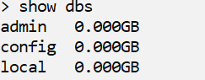

1. **Creating the database**



1. **Display current databse**



1. **Creating and inserting into database collection ‘student’(On**

**the fly)**

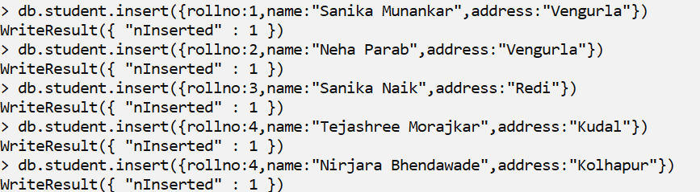

1. **To Retrieve all Entries of ‘student’ collection**

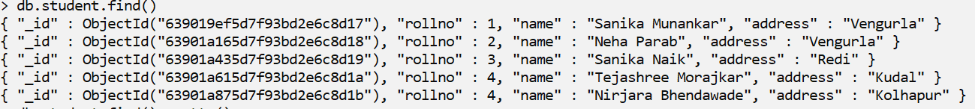

1. **To Display all Entries of ‘student’ collection via pretty() command**

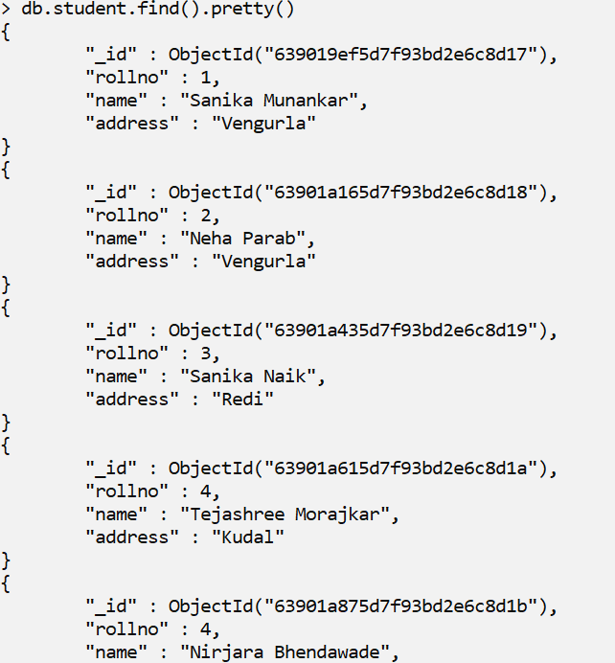

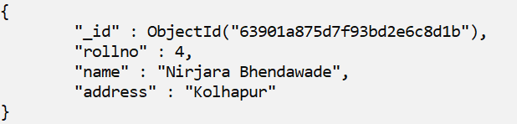

1. **To Display all Entries of ‘student’ using json command**

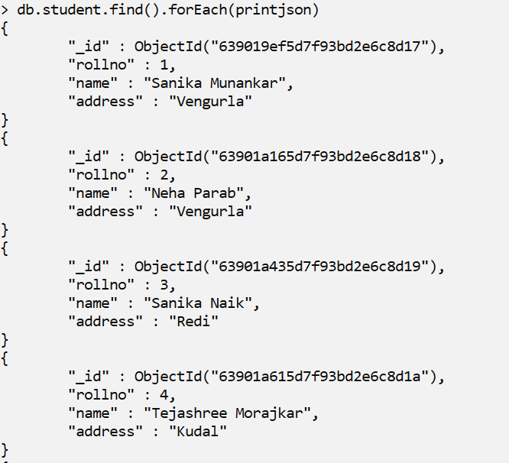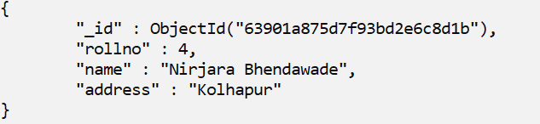

1. **Create Collection**



1. **Show all collections**

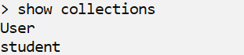

1. **Creating a collection with limited entries**



1. **Adding Entries in ‘user11’(limited) collection**

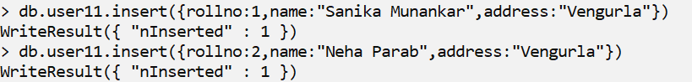



1. **Overriding entries in ‘user11’(limited) collection**





1. **Updating Records in ’student’ collection**



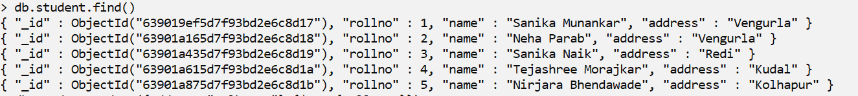

1. **Retrieving Specific Record from ‘student’ collection**



1. **Retrieving records within specified range in ‘student’**

**collection**

1. **Greater than**



1. **Greater than Equal to**



1. **Less than**



1. **Less than equal to**



1. **Not equal to**



1. **Dropping Collection**



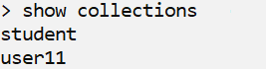

1. **Retrieving Entries in Ascending Order**

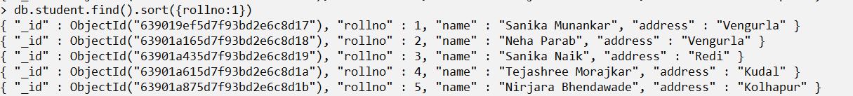

1. **Retrieving Entries in Descending Order**

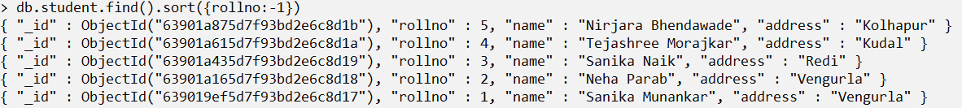

1. **Updating collection using ‘save’ command**

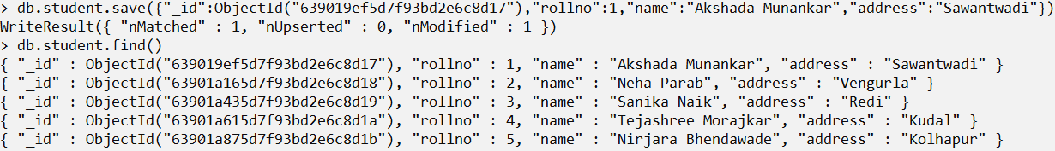

1. **Saving Multiple Entries**

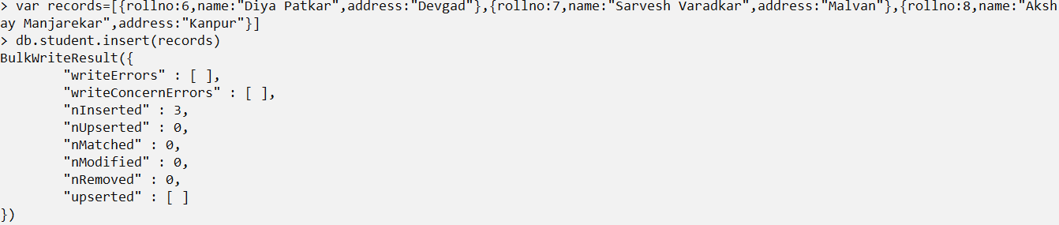

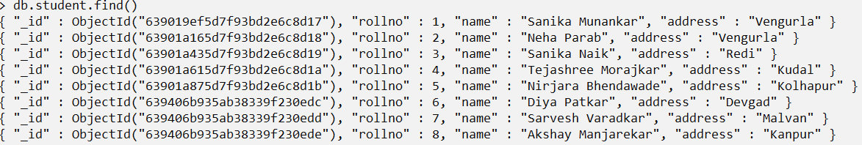

1. **Projection of records**

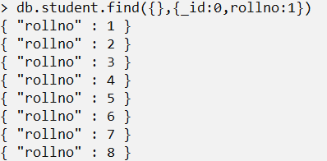

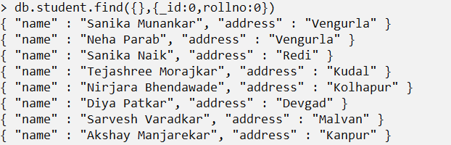

1. **Assigning ObjectId Manually**

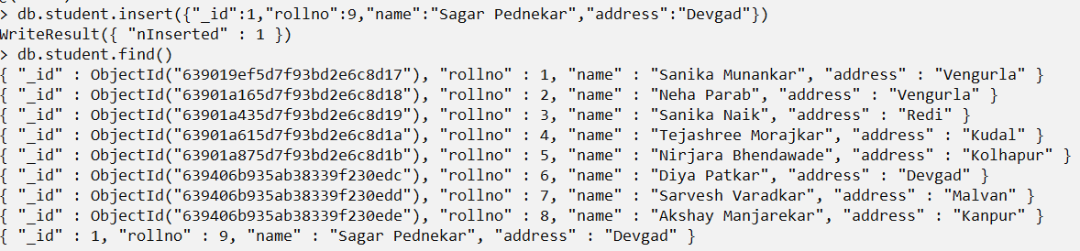

1. **Inserting multiple records via insertMany() command**

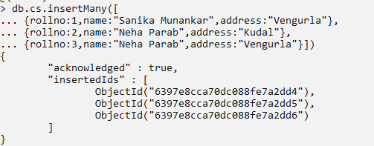



1. **Updating single matching record via findOneAndUpdate()**

**method**

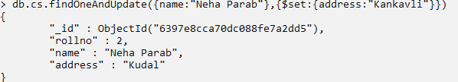



1. **Updating Multiple Records via updateMany()**





1. **Removing a Record via Remove()**





1. **Deleting single matching record via findOneAndDelete()**

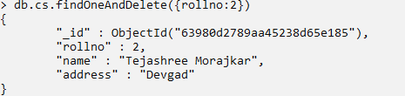



1. **Deleting Multiple Records via deleteMany()**



